**Increment 4**

The following is home page for Smartube….

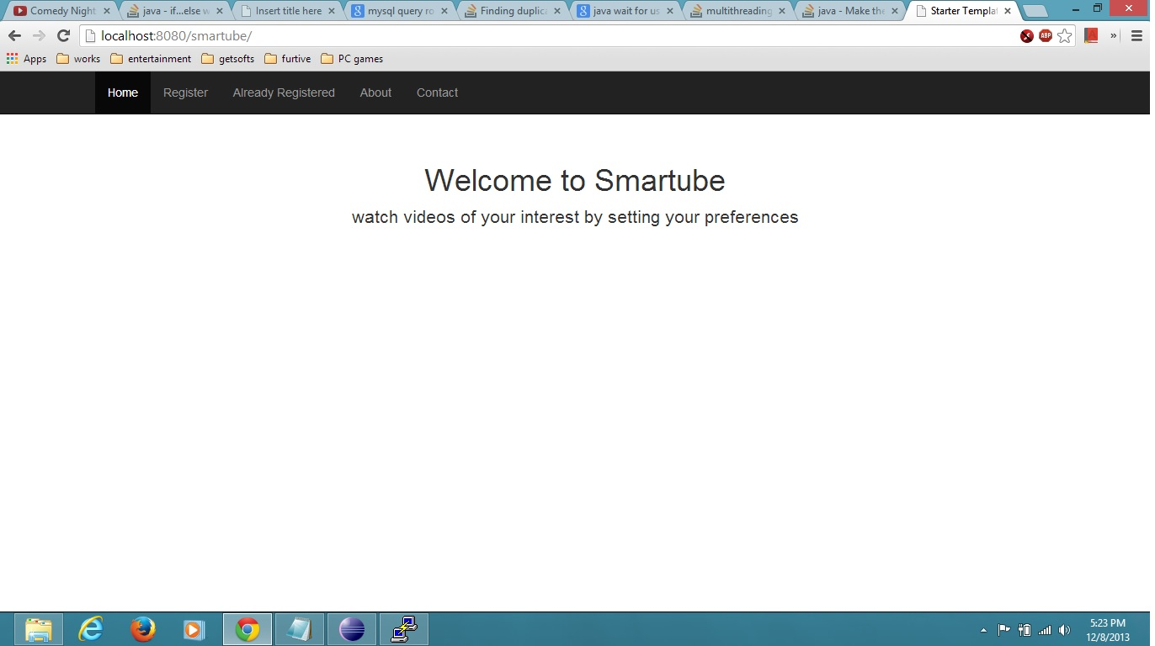

On home page we have following icons. They are

1. Register

2.Already registered

3.About (project)

4.Contact

When we click on “About” icon we get the following page….

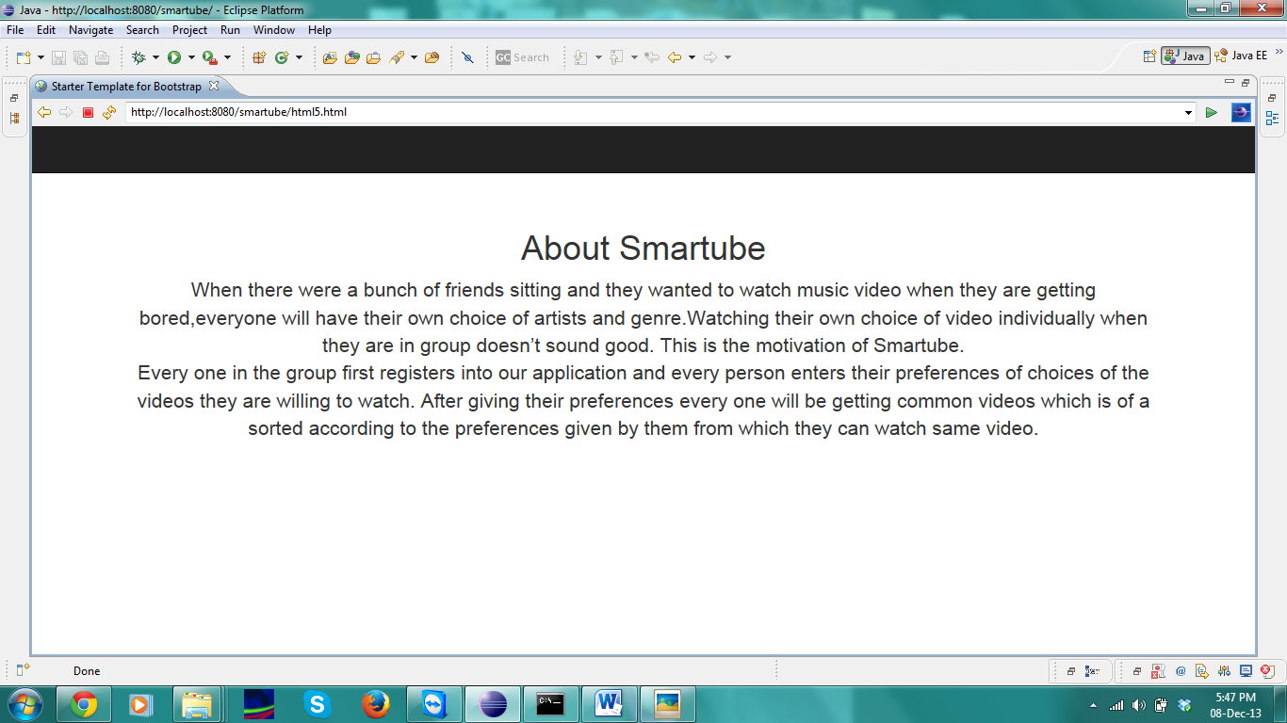

When we click on “contact” icon we get the following page…



Initially, users have to register by entering their respective details in the Registration page. After filling and submitting we get the following page..

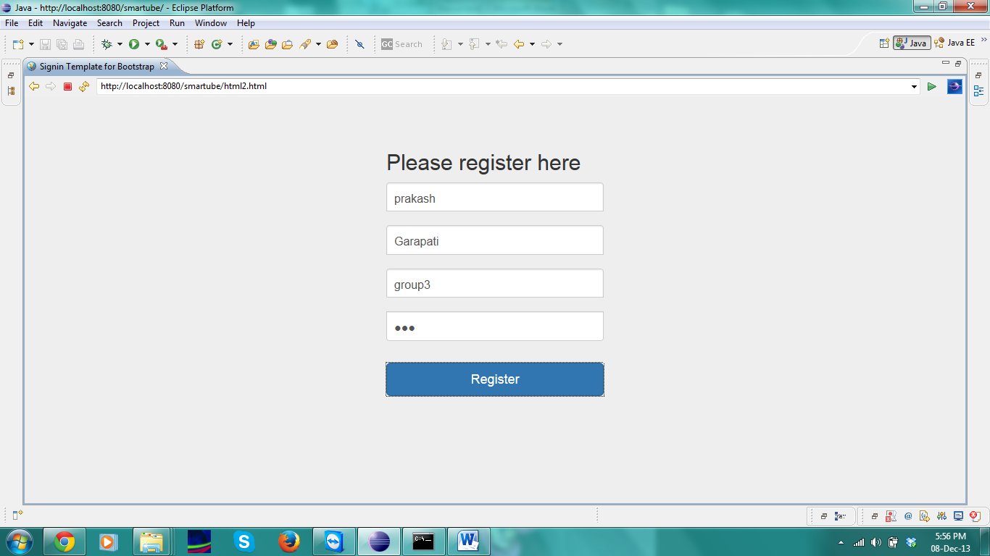

After registration, the user have to enter their choice of interest i.e. language, artist, genre and group name. The following shows that preferences page…..

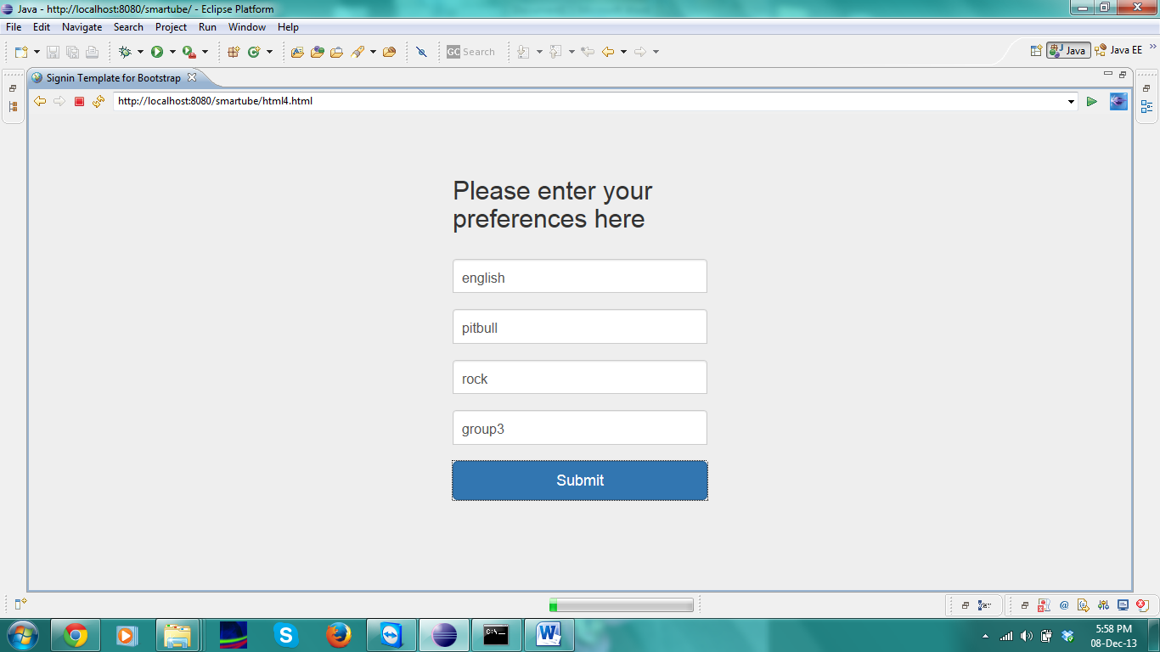

If the users are already registered, they have to click the “Already Registered” button , then they have to enter Group name and Group key…

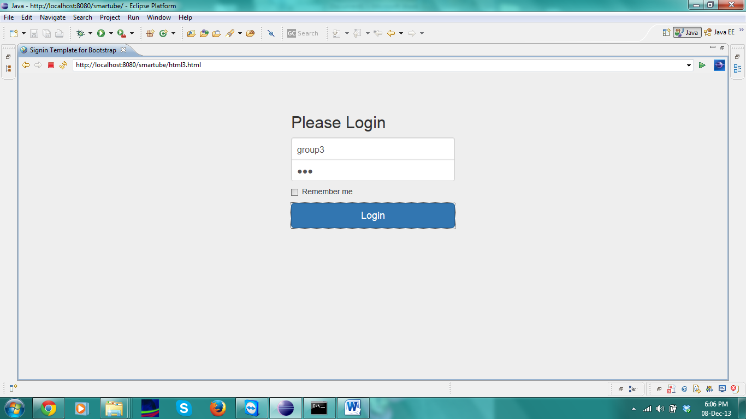

After submitting their details, users have to fill their preferences and they have to submit their details again..

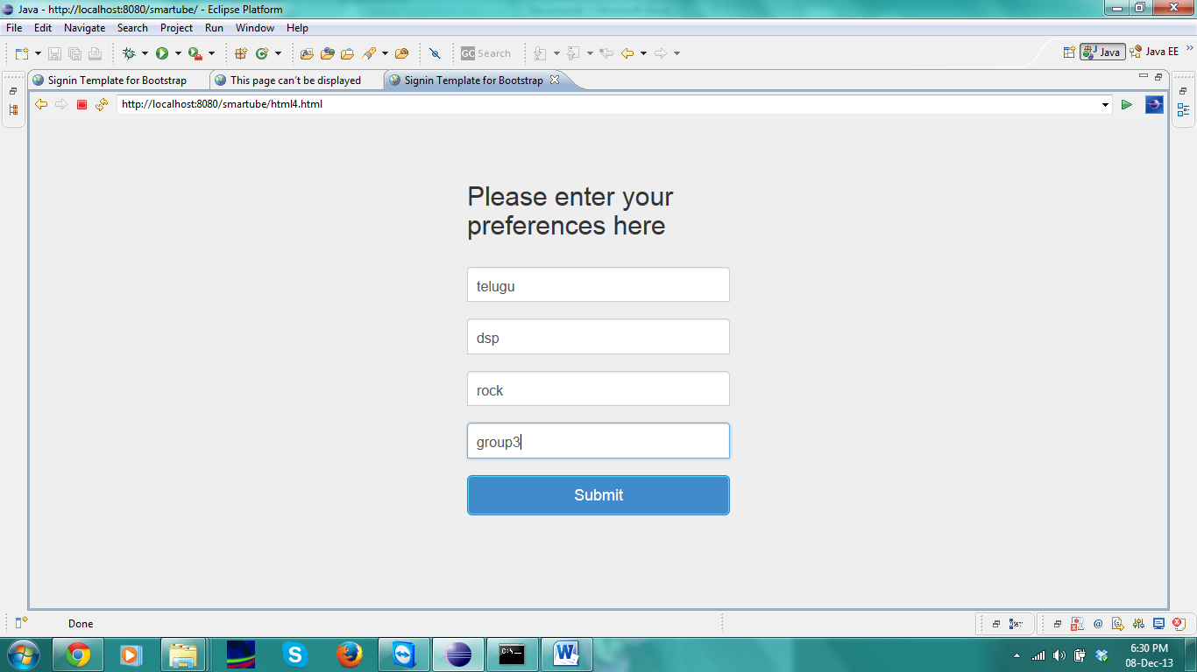

After submitting their all respective details we get the following page with the display of videos and they are displayed based on the users details and it opened in new web page

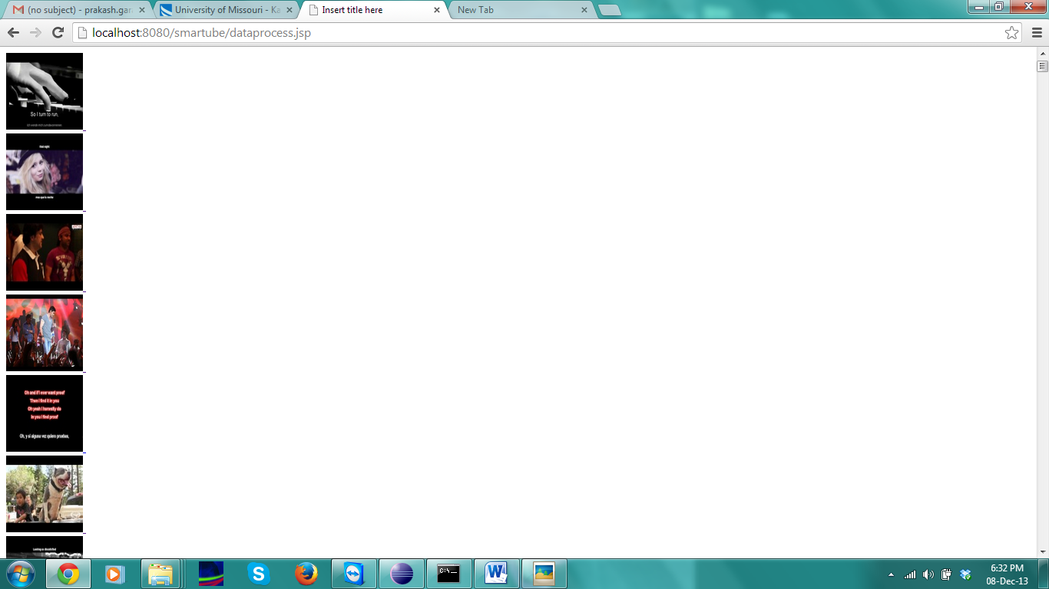

After getting all videos we have to click on any video and it is opened in youtube page which is shown as below….

